FACULTY EVALUATION
Programme Name: SBVP ALUMNI MASTERCLASS - SCALE Module I Online Kenya (20th April 2026 - 24th April 2026)
Session: Reflection and leadership and teams (employees)
Faculty Name: Dr. Cathy Mbidde
No. of Respondents: 18
No. of Participants: 18
Evaluation Parameter | (%) Individual Score | (%) Programme Average
Punctuality (Commencement and Completion of Sessions) | 97 | 96
How well do you understand the core concepts presented? | 89 | 90
Rate your confidence in applying the new skills learnt | 82 | 84
Degree of Faculty preparedness for the sessions | 92 | 94
Content and methodology of the program | 93 | 93
Quality of class and group discussions | 87 | 90
The information presented in the course is relevant to my work (ministry) | 94 | 93
Average scores | 91 | 91

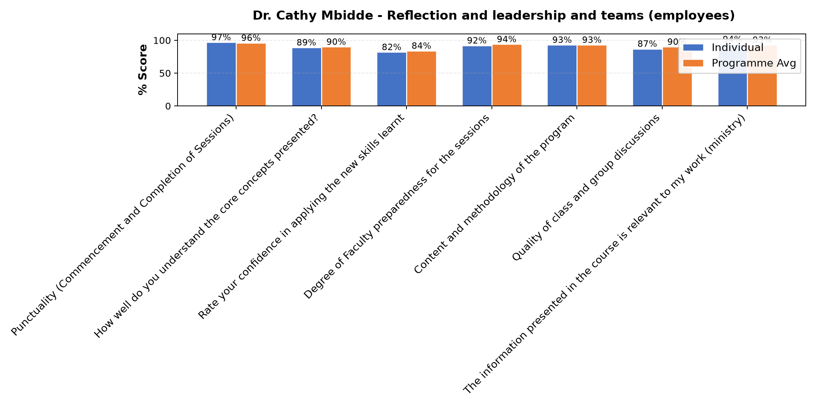

Comments & Feedback
- • Lack of implementation support and financial constraints
- • May be it is me who will fail to put into practice what I have learned today.
- • Review the vision, mission and core values of our institute.
- • Resources
- • The consent from the Authority
- • The structures of our life
- • We have learned that our vision,mission and core values should be precise and easily understood by other people. I foresee some resistance from our leaders since the vision , mission and core values are in most of our documents
- • Lack of confidence.
- • Time constraints
- • Nothing
- • Do not dare to take a risk
- • Ever changing staff in implementing the vision, mission, charism and core values thus a need for continued retooling workshops
SUBMITTED THROUGH:
SBS Evaluation Automation System

